Exercise 1: Control Structures:
Scenario 1: Apply 1% Discount for Customers Above 60
BEGIN
FOR cust_rec IN (SELECT CustomerID, Age, LoanInterestRate FROM CUSTOMERS) LOOP
IF cust_rec.Age > 60 THEN
UPDATE CUSTOMERS
SET LoanInterestRate = LoanInterestRate - 1
WHERE CustomerID = cust_rec.CustomerID;
END IF;
END LOOP;
COMMIT;
END;
/
Output:
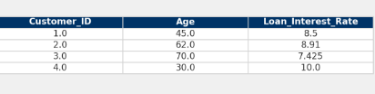
Scenario 2: Promote to VIP if Balance > $10,000
BEGIN
FOR cust_rec IN (SELECT CustomerID, Balance FROM CUSTOMERS) LOOP
IF cust_rec.Balance > 10000 THEN
UPDATE CUSTOMERS
SET IsVIP = 'Y'
WHERE CustomerID = cust_rec.CustomerID;
END IF;
END LOOP;
COMMIT;
END;
/
Output:
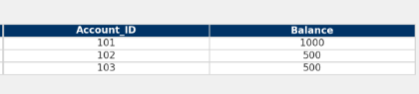
Scenario 3: Reminders for Loans Due in Next 30 Days
DECLARE
v_today DATE := SYSDATE;
v_due_limit DATE := SYSDATE + 30;
BEGIN
FOR loan_rec IN (
SELECT L.LoanID, L.CustomerID, C.CustomerName, L.DueDate
FROM LOANS L
JOIN CUSTOMERS C ON L.CustomerID = C.CustomerID
WHERE L.DueDate BETWEEN v_today AND v_due_limit
) LOOP
DBMS_OUTPUT.PUT_LINE('Reminder: Loan ID ' || loan_rec.LoanID ||
' for customer ' || loan_rec.CustomerName ||
' is due on ' || TO_CHAR(loan_rec.DueDate, 'DD-MON-YYYY'));
END LOOP;
END;
/
Output:
